Kindergarten, 1st & 2nd Supply List
CLASSROOM SUPPLIES (Shared – don’t label)
- 2 packages of pre-sharpened Pencils
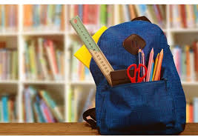
- 2 packages of Expo Dry erase markers (fine tip)
- 2 boxes of Kleenex
- scissors
- Wet Wipes / Baby Wipes (at least 3 large packages)
- 1 ream of white copy paper
- Shoes should be Velcro or slip on ONLY
(Students may have shoe laces if they can independently tie them tight by themself)
Outdoor SUPPLIES – Please put name on water bottle, clothing & boots
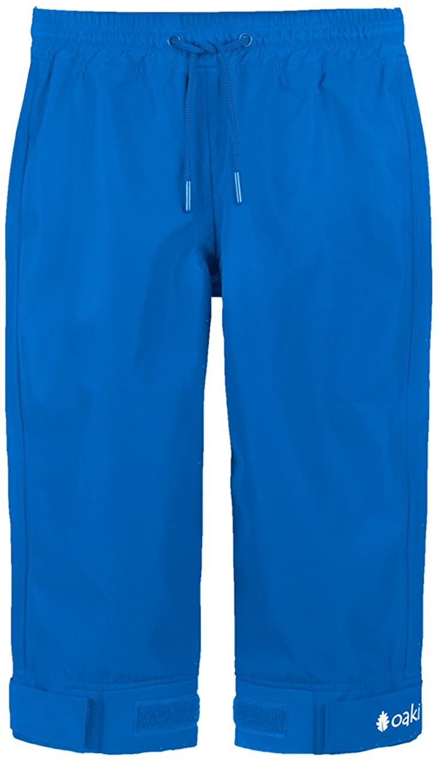
- 2 large cans of bug spray
- 1 can spray sunscreen
- 1 reusable water bottle
- Rain Boots
- Durable Raincoat (Recommended Brands: Oaki, Columbia, Playshoe)
- Durable Rain Pants (Recommended Brands: Oaki, Columbia, Playshoe)
- Change of old clothes (non-uniform) in plastic zip-lock bag with name on it (Shirt, Pants, Underclothes, and socks)

